Lab 03 – Networking

E/21/291

Iii]

A gateway IP address was used to connect static routing.

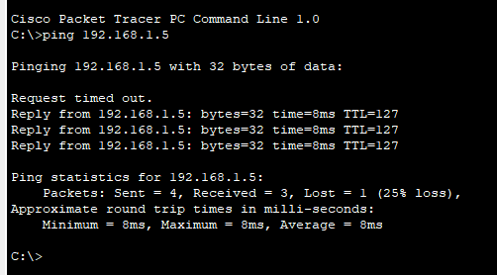

Iv]

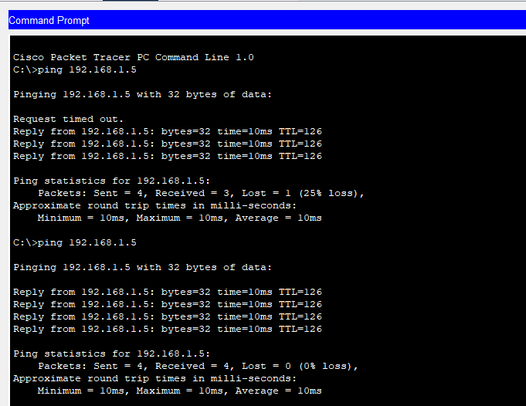

v] Briefly explain why RIP is not used in Internet-scale routing.   
  
RIP is an old network routing protocol that was used to determine the best path for forwarding data.However, this is not suitable for broad networks since it is limited to 15 hopes.moreover the delay in routing updating and slow convergence RIP is not used in present day as a routing protocol.  
  
[vi] State the purpose of Autonomous Systems (AS) in routing.

Autonomous systems are used to organise and scale internet [routing. In](http://routing.in) this system the BGP(Border gateway Protocol) allows to exchange summarized routes so that each and every router won't need to know their corresponding address.

[vii] Briefly explain how the OSPF routing algorithm operates.

OSPF is a link state routing protocol that is used to calculate the best path to each network.  
Initially, each router will build a map of the entire network topology using link state advertisement.then the topology will be represented as a graph. After that the Dijkstar’s algorithm will find the shortest path building an OSPF routing table.